35.55: a) Intensified reflected light means we have constructive interference. There is one half-cycle phase shift, so:
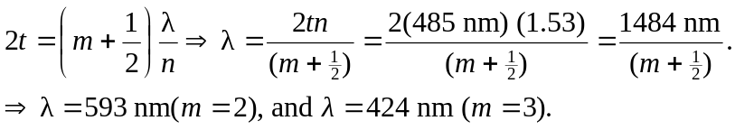
b) Intensified transmitted light means we have destructive interference at the upper surface. There is still a one half-cycle phase shift, so:
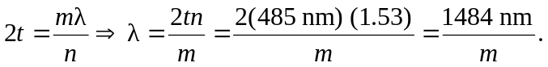
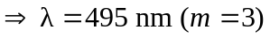
is the only wavelength of visible light that is intensified. We could also think of this as the result of internal reflections interfering with the outgoing ray without any extra phase shifts.

